

PHINMA Araullo University - South
College of Information Technology
Bachelor of Science in Information Technology
S.Y. 2026-2027 | First Semester

ITE 302 Information Assurance and Security 1 | Period 1 Requirements

EasyNotes System
Project Documentation

Documented by:

Name: De Guzman, John Christian P.  Student Number: 01-2627-030993  Contact Number: 09977837472  Permit Number: 518731389681 | Name: Viloria Art Adrian F  Student Number:01-2627-03142  Contact Number: 09682644658  Permit Number: 522291395290
Name: Manabat, Jackie G.  Student Number: 01-2627-031095  Contact Number: 09677734960  Permit Number: 519751391041 | Name:  Student Number:  Contact Number:  Permit Number:

Submitted to:

Jericho Coronel Bernardo
Subject Teacher



PHINMA Araullo University - South
College of Information Technology
Bachelor of Science in Information Technology
S.Y. 2026-2027 | First Semester

ITE 302 Information Assurance and Security 1 | Period 1 Requirements
EasyNotes System | Project Documentation

- Project Information
Project Title
EasyNotes System
- Development Team
- De Guzman, John Christian P.
- Villoria, Ian
- Manabat, Jackie*
- Proposed Information System
Student Information System
- Project Description
Easy Notes is a simple and practical note-taking strategy that summarizes long topics into short, clear, and easy-to-understand notes. It focuses on the most important concepts, key details, and essential information while keeping the original meaning and context of the lesson. Instead of copying lengthy explanations, students organize the information using short phrases, keywords, and simple statements. This makes lessons easier to read, understand, remember, and review, especially before quizzes and examinations

II. Problem Statements
Instructions: 1 paragraph. 5–8 sentences. Identify and describe at least three (3) existing problems or challenges that the organization or its users currently experience and that your proposed information system aims to solve. Explain how each identified problem affects the organization's operations, services, or data management. Then, briefly discuss how your proposed information system will address these problems through its key features, functionalities, or security measures. Ensure that the identified problems are realistic, relevant to the chosen organization, and aligned with the objectives of the proposed project.

Problem Statement 1: Users often find it difficult to understand lengthy learning materials because important concepts are mixed with too much information. They need to spend a significant amount of time reading the entire material before identifying the main ideas. This can make studying more challenging, especially when preparing for quizzes, examinations, or class discussions. Long and complicated explanations may also cause users to lose focus and have difficulty remembering important details. As a result, the learning process becomes less efficient and more time-consuming. The proposed Easy Notes Information System will address this problem by presenting lengthy topics in shorter and clearer forms while preserving the original meaning and context.

Problem Statement 2: Creating notes from lengthy learning materials can be a time-consuming task for users. Students often copy entire sentences or paragraphs instead of selecting only the most important information. This may result in notes that are still lengthy, repetitive, and difficult to review. Users may also spend more time organizing their notes instead of focusing on understanding the lesson. The absence of a simple system for summarizing important information can therefore affect their study habits and productivity. The proposed Easy Notes Information System will help users create concise notes by focusing on key concepts, important details, and essential information while retaining the context of the original topic

Problem Statement 3: Users may also experience difficulty in organizing and accessing their notes when information is stored in different files, notebooks, or locations. Searching for a specific topic can take time, particularly when users have accumulated many notes from different lessons or subjects. Disorganized notes can also make it difficult to review information efficiently when it is needed. In some cases, important notes may be misplaced, duplicated, or forgotten because there is no centralized system for managing them. This problem can affect the user's ability to retrieve and review information quickly and effectively. The proposed Easy Notes Information System will provide a centralized platform where users can create, organize, store, and easily access summarized notes, making information management more convenient and efficient.

III. Information Assurance and Security Plan

The Easy Notes Information System is a technology-based platform designed to help users transform lengthy learning materials into shorter and easier-to-understand notes while maintaining the original meaning and context. The system will ensure that summarized information is properly stored, organized, and accessible to authorized users through digital devices. To protect the information, the system will apply appropriate security measures involving user authentication, access control, data protection, and regular backups.
IA Principle | Planned Security Measure
Confidentiality | The system will protect users' accounts, notes, and other stored information from unauthorized access. User credentials will be secured through passwords and authentication mechanisms. Access to specific information will be limited according to the user's assigned role.
Integrity | The system will ensure that summarized notes remain accurate, complete, and consistent with the original learning materials. Only authorized users, such as teachers or administrators, will be permitted to create, edit, or delete official notes. This will help prevent unauthorized changes or inaccurate information from being stored in the system.
Availability | The system will be designed to allow authorized users to access summarized notes conveniently using computers, tablets, or mobile devices. Regular maintenance and monitoring will help keep the system functional and accessible. This will support students and teachers in quickly reviewing important information whenever needed.
Authentication | The system will provide secure login procedures to verify the identity of users. Different access permissions may be assigned depending on the user's role, such as administrator, teacher, or student. This will prevent unauthorized individuals from modifying or accessing restricted information.
Non-repudiation | The system will monitor user activities and system access to identify unusual or unauthorized activities. Administrators may review login records and other relevant system activities when necessary. Regular security checks and updates will also be performed to reduce potential security risks.

IV. Secure Coding and Defensive Programming Plan

The Easy Notes Information System will apply secure coding and defensive programming practices to ensure that the system is safe, reliable, and easy to use. Since the system is designed to summarize lengthy learning materials into shorter and more understandable notes, it will protect both the users and the information stored in the system. All data entered by users will be properly checked and validated to prevent incorrect, harmful, or unauthorized information from being saved. The system will also use secure login procedures and access controls to ensure that only authorized users can create, edit, or manage notes. To further protect the system, secure database practices will be applied to prevent common threats such as unauthorized access, malicious input, and data manipulation. If errors or unusual activities occur, the system will provide appropriate error messages without revealing sensitive information and will keep necessary records for monitoring and troubleshooting. Regular backups will also be performed to prevent the loss of important notes caused by accidental deletion, system errors, or technical problems. Through these security measures, Easy Notes will provide a convenient, trustworthy, and secure platform where users can create, organize, and access summarized learning materials.



PHINMA Araullo University - South
College of Information Technology
Bachelor of Science in Information Technology
S.Y. 2026-2027 | First Semester

Name: Permit Number:


Name: Permit Number:
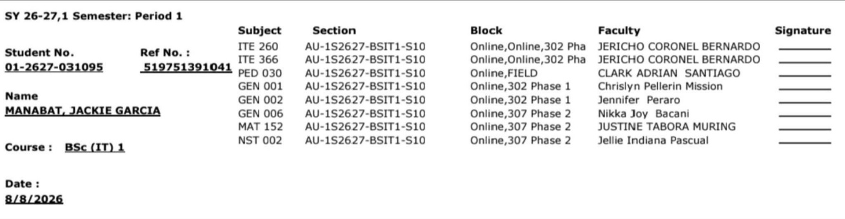

Name: Permit Number:
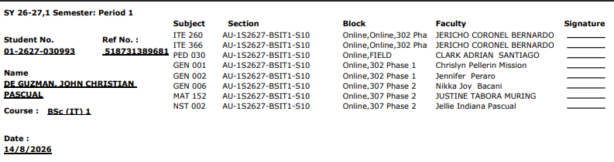

***************************DO NOT PRINT THIS PAGE****************************
Pattern and Document Styling:
Spacing: Single spacing on paragraphs
Font and Images: Black for text, full colour or grayscale for pictures and graphs
- Title: 12 Arial Font Bold
- Subtitle: 11 Arial Font Bold, Italic
- Regular Text: 10 Arial Font
- Code/ Commands: 10 Consolas Font
Paper and Margins: Print on short bond paper with 1-inch side margins
Use all black for all text, RED TEXT are only used to highlight examples.

Rubrics
Project 1 Check-in Grading Criteria
Criteria | Description | Points
Project Information | Clearly presents the project title, development team, proposed information system, and project description. The proposed system is realistic, well-defined, and relevant to Information Assurance and Security. | 20
Problem Analysis | Identifies and explains at least three realistic problem statements. Each problem is clearly defined, relevant to the proposed system, and accompanied by an appropriate proposed solution. | 25
Information Assurance and Security Plan | Demonstrates appropriate application of the five Information Assurance principles (Confidentiality, Integrity, Availability, Authentication, and Non-repudiation). Security measures are realistic, relevant, and aligned with the identified problem statements. | 30
Secure Coding and Defensive Programming Plan | Clearly explains the secure coding and defensive programming practices that will be implemented. The discussion demonstrates how these practices address the identified problems and improve the security and reliability of the proposed system. | 20
Organization, Formatting, and Professionalism | Documentation is complete, well-organized, follows the required format and instructions, and demonstrates professional writing with minimal grammatical and formatting errors. | 5
TOTAL |  | 100
Performance Rating Guide
Score | Performance Level | Description
90–100 | Excellent | Demonstrates a comprehensive understanding of Information Assurance concepts. All sections are complete, accurate, well-organized, and professionally presented with clear justifications.
80–89 | Very Good | Demonstrates a strong understanding of the required concepts. Most sections are complete and accurate, with only minor omissions or areas for improvement.
75–79 | Satisfactory | Demonstrates an acceptable understanding of the concepts. Some sections require additional detail, clarification, or stronger alignment with the proposed project.
Below 75 | Needs Improvement | Demonstrates limited understanding of the required concepts. Several sections are incomplete, inaccurate, or do not meet the project requirements.

